STAKEHOLDER &
VALUE CHAIN ANALYSIS
Pigeon Pairing & Performance Tracker
Who the project affects, and where the system adds value for the client
Prepared for: Gerard Koopman
Prepared by: Osinavhe Akhigbe, Silvio Ariclenes António Feio, Rodrigo de Araújo Castanheira, Caleb Gaïtou, NHL Stenden University of Applied Sciences, Emmen
Course: Project Year 2
Date: 29/10/2026
Version: 1.0

Contents
1. Stakeholder Analysis 3
1.1 Stakeholders 3
1.2 Power/Interest Grid 4
1.3 Strategy per Group 4
1.4 Connection with the Project 4
2. Value Chain Analysis 5
2.1 Primary Activities 5
2.2 Support Activities 5
2.3 Margin 5
2.4 Where the System Creates Value 6
2.5 Value Proposition 6
3. References 6

1. Stakeholder Analysis
The client Gerard Koopman, the examiners and the project group are the stakeholders to manage closely; the data suppliers CompuClub and OneLoftRace.live are the biggest risk, because they have high power over the system's input but no interest in the project. Stakeholders are classified with Mendelow's power/interest grid (Mendelow, 1981).

1.1 Stakeholders
Table 1 – Stakeholders of the Pigeon Pairing & Performance Tracker
Stakeholder | Type | Role in the project | Interest (what they want) | Influence
Gerard Koopman (client) | Internal, primary | Client, end user, Product Owner in spirit | A reliable ranking of his ~70 breeding pairs before the pairing season in December, without entering data twice | Decides on requirements, approves the project plan, judges the product
Project group IT2D | Internal, primary | Designs, builds and tests the system | A working product that satisfies the client and passes the assessment | Decides on design, technology and planning
Teachers / examiners (M. Pomp, F. van der Meulen) | Internal, primary | Supervise the process and assess the products | Correct use of Scrum, complete documents, a working MVP | Decide on the grade and whether the module is passed
CompuClub (Compustam) | External, secondary | Supplier of pigeon, ring number and parentage data | Protection of its software and data; its terms forbid copying or automatic collection without written permission | Can allow or refuse access to the data the system depends on
OneLoftRace.live (BENZING) | External, secondary | Platform that publishes one-loft race results | Normal, reasonable use of its public pages and API | Can change or close the API at any time, which breaks olr:sync
One-loft race organisers (e.g. Thailand, Portugal, Qatar) | External, secondary | Look after the youngsters and organise the races | Entries from breeders; paid entry fees | Decide the race stages and how results are published
Buyers of pigeons | External, secondary | Buy pigeons from the client, for example at auction | Proof that a pigeon comes from a strong pair | Indirect: a strong pair ranking makes the client's birds more valuable
Other breeders / future users | External, secondary | Possible users if the system is offered more widely | A similar tool for their own birds | Low now; relevant for further development
DNA testing company | External, secondary | Checks parentage from feather samples | Orders for DNA tests | Low; only relevant if Q-07 is answered yes
NHL Stenden | Internal, secondary | Institution that runs the course | Students meeting the learning outcomes | Sets deadlines, rules and the assessment framework

1.2 Power/Interest Grid
Figure 1 places every stakeholder on Mendelow's grid. The quadrant decides the strategy in Table 2.
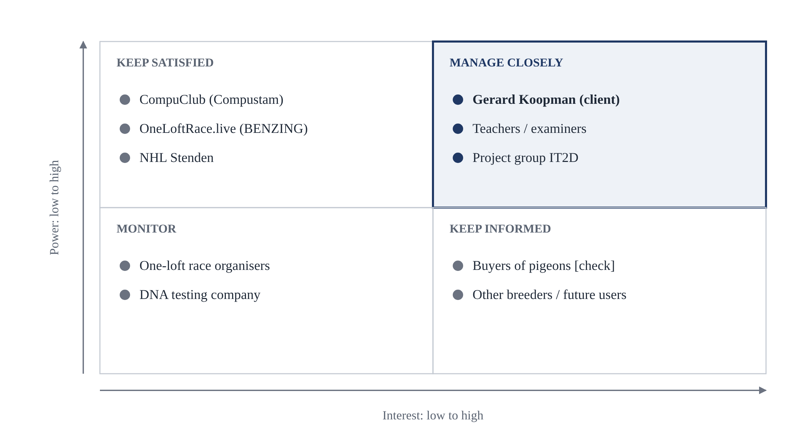
Figure 1 – Power/interest grid (Mendelow, 1981)

1.3 Strategy per Group
Table 2 – Strategy per stakeholder group
Group | Strategy | In practice
Manage closely | Involve them actively and often | A review with the client at the end of every sprint; written confirmation of requirements (Appendix A); weekly progress demos and timesheets for the teachers; sprint planning and daily stand-ups within the team
Keep satisfied | Respect their rules; ask before relying on them | No scraping of CompuClub, only a CompuClub export file; infrequent requests to OneLoftRace.live with cached results; permission for API use confirmed
Keep informed | Share results when relevant | The ranking and race records can later be shown to buyers and other breeders
Monitor | Watch for changes that affect the system | Check whether organisers change how they publish results; revisit DNA storage if Q-07 changes

1.4 Connection with the Project
- The client is the most important stakeholder. Every user story (US-01 to US-11) comes from his needs, and the ranking weights (Q-04, Q-05) cannot be set without his feedback.
- The external data suppliers are the biggest risk. If CompuClub does not allow an export, or OneLoftRace.live changes its API, the system loses its input. This is why every data source has a fallback (Table 7 of the design document): manual entry or CSV upload.
- The examiners and the client judge different things. The examiners assess process and documentation, the client whether the product works. Sprint 4 therefore reserves time for documentation as well as development.

2. Value Chain Analysis
The client's value is decided by one choice at the start of the chain: which pairs to breed from. The system adds the most value by feeding race results back into that choice. The analysis uses Porter's value chain (Porter, 1985): primary activities produce and race the pigeons; support activities make them possible.

2.1 Primary Activities
Table 3 – Primary activities of the client's one-loft racing operation
Activity | What it means for the client | Current problem | Value added by the system
Inbound logistics | Selecting and pairing breeding pigeons for the new season (December–January); buying feed and medicine | Pairs are chosen from memory | High: the pair ranking shows which pairs to keep, re-pair or replace
Operations | Breeding: eggs, hatching, ringing after a few days, registering in CompuClub, raising and weaning youngsters | Fertility and survival are not recorded together with results | Medium: fertility and survival are recorded per pair per season
Outbound logistics | Sending youngsters to one-loft races abroad and paying the entry fee per pigeon | Entry fees are paid without knowing which pairs give the best chances | Medium: money goes to youngsters from proven pairs
Marketing & sales | Selling pigeons, for example at auction; reputation through results; prize money | No overview of which pairs produce winners | Medium: a ranking and race record per pair support the value of offspring
Service | Following results online; pedigree information for buyers | Results are scattered over several websites and countries | High: all one-loft results are linked to the pigeon and its parent pair in one place

2.2 Support Activities
Table 4 – Support activities
Activity | What it means for the client | Value added by the system
Firm infrastructure | A small operation run by the client himself: planning, finances (entry fees against prize money), administration | One place for the records of the international birds
Human resource management | The client's 30 years of experience; knowledge is mainly in his head | Knowledge is stored as data and no longer depends on memory
Technology development | CompuClub (pedigree, Dutch results), OneLoftRace.live (results abroad), DNA testing | Main contribution: connects CompuClub data with one-loft results
Procurement | Feed, medicine, rings, race entries, DNA tests, CompuClub licence | Indirect: fewer wasted entry fees

2.3 Margin
The margin is the income from prize money and sales minus the cost of entry fees, feed and care. Every youngster sent abroad costs an entry fee, and only good results bring money back.

2.4 Where the System Creates Value
Today the chain is not closed: race results (outbound logistics, service) do not flow back into pair selection (inbound logistics). The link exists only in the client's memory. Figure 2 shows the chain and the loop the system closes.
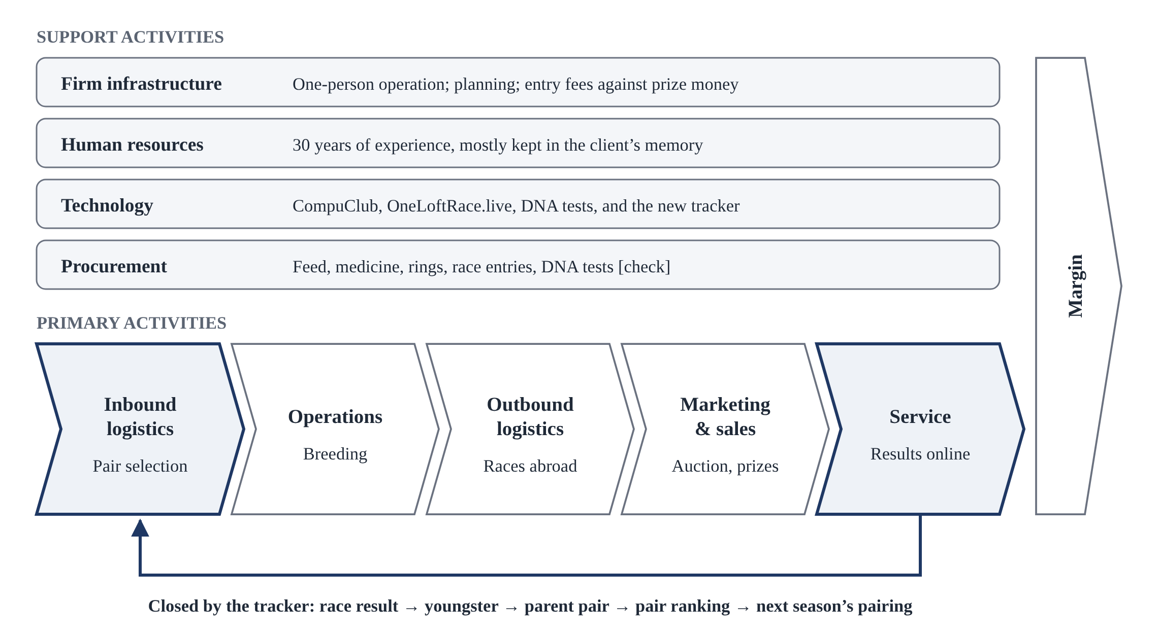
Figure 2 – Value chain of the client's one-loft racing operation (Porter, 1985)

2.5 Value Proposition
For a breeder who sends youngsters to one-loft races abroad, the Pigeon Pairing & Performance Tracker combines CompuClub pedigree data with one-loft race results into one ranking of breeding pairs. Pairing decisions are then based on data instead of memory, so entry fees are spent on youngsters from pairs with a proven chance of success.

3. References
Freeman, R. E. (1984). Strategic management: A stakeholder approach. Pitman.
Mendelow, A. L. (1981). Environmental scanning: The impact of the stakeholder concept. In Proceedings of the Second International Conference on Information Systems (pp. 407–418).
Porter, M. E. (1985). Competitive advantage: Creating and sustaining superior performance. Free Press.

